Hotel “Olympiyskaya” –official hotel
World Cup in Ski Orienteering and World Ski Orienteering Championship

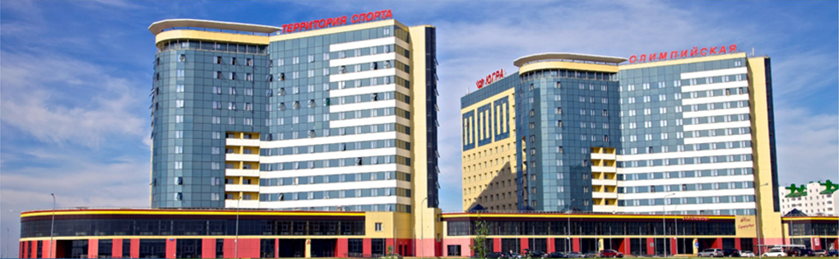
Address:
45 Engels St., Khanty-Mansiysk, Khanty-Mansiysk Autonomous Okrug – Ugra, 628012 Russia

Booking information:
To book rooms at the hotel please send your accommodation request to the following e-mail: accommodation@ugrasport.com
Responsible person for accommodation – Anna Ryadnova, tel.: 8 3467 – 361402.
The hotel “Olympiyskaya” is situated within 5 minutes' drive from the venue of the Tournament – Tennis Development Centre, and also within 7-10 minutes’ walking distance from the center of the city.
The hotel consists of 418 rooms (11 suites, 11 junior suites, 44 single rooms, 331 double rooms, and 21 rooms for disabled people. Total number of available bed space is 770.

Double room is a spacious room with a TV-set, a table lamp, a telephone, beds, bedside tables, a mini-bar, a safe, a wardrobe, a mirror, a magazine table, a shower unit and other furniture and appliances.

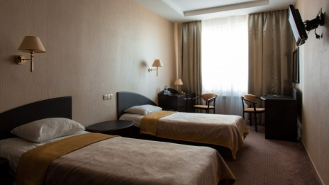 | 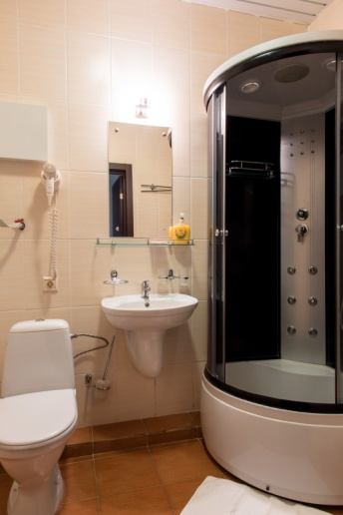
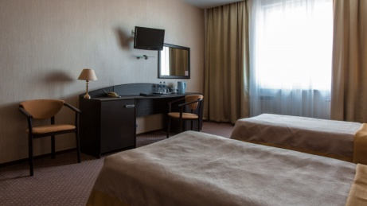

Services:
Restaurant «Olymp»
Lobby bar
Luggage room
Billiard
Free Wi-Fi
Car parking
Gym
Laundry

Conditions:
- Free booking.
- Check-out time – 12:00.
- Payment terms:
Accommodation should be paid directly to the hotel upon arrival. Credit cards VISA Int. (VISA, Electron), Europay Int. (Eurocard / MasterCard) are accepted.
Meals should be paid directly to the restaurant. Credit cards VISA Int. (VISA, Electron), Europay Int. (Eurocard / MasterCard) are accepted.
- Travel to Khanty-Mansiysk

The air companies “Utair” and “Aeroflot” make regular flights from Moscow to Khanty-Mansiysk and back. You can buy the air tickets of these companies on the sites:
“Aeroflot” - https://www.aeroflot.ru
“Utair” - https://www.utair.ru/en
Transfer for participants from the airport to the hotel “Olympiyskaya” and back is free.
Responsible person for transport – Tatyana Slovar, tel.:83467-361212,
e-mail: transportation@ugrasport.com.
The nearest airports to Khanty-Mansiysk are Surgut (300 km), Tyumen (600 km), Yekaterinburg (1000 km).
The nearest railway stations are Pyt-Yakh (248 km) and Demyanka (220). You can go from Pyt-Yakh by train to 16 directions.

